To Identify Lowercase Letters Using Lex Program
AIM:
To write a Lex program to identify and display lowercase letters from the given input.
PSEUDOCODE:
- Start.
- Define the pattern [a-z] to identify lowercase letters.
- Read the input lexeme from the user.
- If a lowercase letter is found, display it as a lowercase letter.
- Ignore other characters.
- Stop when a newline is encountered.
- Stop.

Program:
%{
%}

%%
[a-z] {printf("%s is lowercase", yytext);}
\n {return 0;}
. {}
%%

int yywrap(){return 1;}

int main()
{
printf("enter the lexeme:");
yylex();
return 0;
}

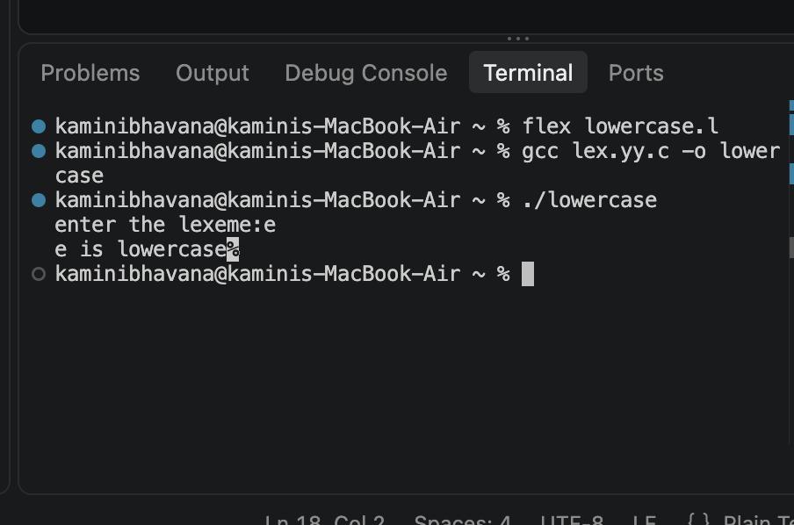
OUTPUT:

